Today I will be teaching you on how to make it so that when you have a character moving the camera will follow your movement and stay with the player. For this exercise I have created a simple project where we have a 3D Plane and Cube, I have renamed them as Floor and Player to make things simpler, I have also applied my movement script from an earlier project called [Zip. Name], which I will be leaving in the file if you want to learn that.

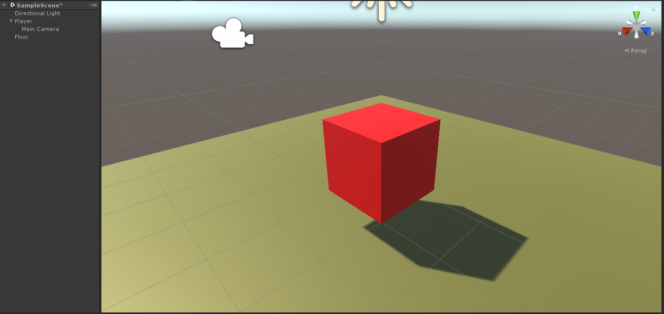Now you can just attach the camera to the player and thus the camera will stay behind it. But if we want the camera to keep up with the player if we were doing some high speeds or something like that we would need to give the camera a bit of help so we will do that today.

**Step by Steps:**

1. First of all, we can start by creating a new C# script called **CameraFollow** and then attach it to our camera, then double click on the script to open it up.
2. Unlike most of my tutorials I will be continuing this in PowerPoint as the images have better resolution as well as that I am going to do a step by step tutorial with the code and explain it along the way.